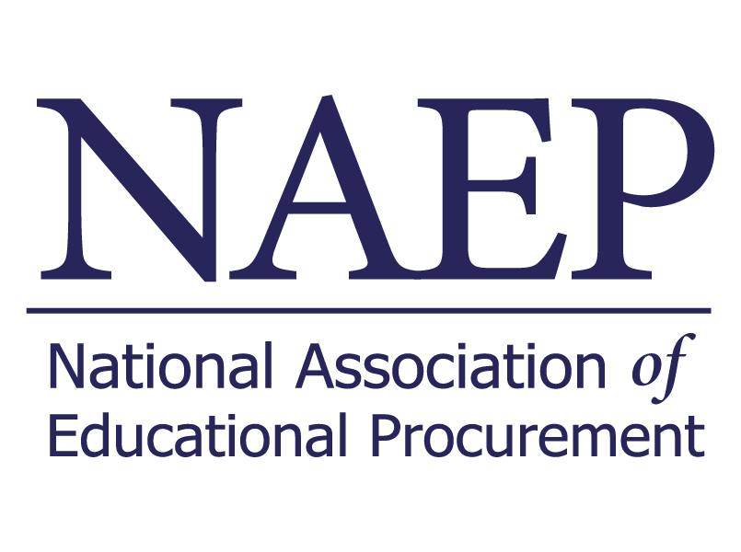

[Your Name] [Date][Your Title]   
[Your Institution]

[Recipient's Name]   
[Recipient's Title]

Subject: Justification for Attendance at NAEP EPIC 2024 Conference

Dear [Recipient's Name],

I am writing to formally request approval to attend the NAEP (National Association of Educational Procurement) EPIC 2024, Educational Procurement Innovation Conference, scheduled to take place from March 17th - 20th at the Gaylord National Harbor in Maryland. As an integral member of our team at [Your Institution], I believe that participating in this event is crucial for my professional development and will contribute significantly to our department's growth.

The EPIC 2024 conference is renowned for its commitment to fostering innovation, providing valuable insights, and facilitating unparalleled networking opportunities within our industry. The diverse range of sessions, workshops, evening events, a service project, and the Awards Luncheon promise to be a comprehensive and enriching experience.

Attending the EPIC 2024 conference will allow me to:

* **Stay Informed:** Gain insights into the latest trends, industry best practices, and emerging technologies through a diverse range of sessions.
* **Network:** Connect with industry leaders, peers, and potential collaborators during structured sessions and social events, while fostering professional relationships that can benefit our organization.
* **Learn:** Participate in workshops and the Emergentics Pre-Conference Session to enhance my skills, bringing valuable knowledge back to our team.

Enclosed is an estimate of associated costs, including registration, accommodation, and travel expenses. I have considered these factors and am committed to maximizing the value of this investment for our institution's benefit.

I appreciate your consideration of this request and am happy to provide additional information or discuss this further if needed. Thank you for your time and support in advancing my professional growth and our institution's success.

Sincerely,

[Your Name]   
[Your Title]   
[Your Institution]