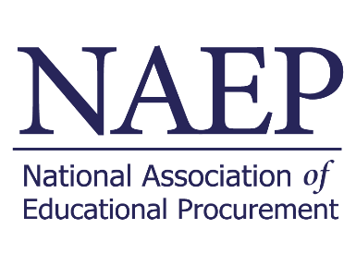

[Date]

[Recipient's Name]  
[Recipient's Title]  
[Recipient's Organization]

Dear [Recipient's Name],

I hope this letter finds you well. I am writing to request approval for my attendance at the Educational Procurement Innovation Conference, EPIC25, hosted by the National Association of Educational Procurement (NAEP).

**Conference Background**: EPIC25 is a leading event in higher education procurement, gathering key decision-makers, thought leaders, and innovators in the field. The conference will focus on shaping the future of procurement in education through engaging sessions, meaningful networking opportunities, and an exhibition showcasing the latest advancements in the industry.

**Rationale for Sponsorship/Attendance:**

* **Strategic Alignment:** EPIC25 aligns seamlessly with our organizational goals and initiatives in advancing higher educational procurement practices. The conference provides a unique platform to showcase our institutions commitment to excellence and innovation in the industry.
* **Networking Opportunities:** Participation in EPIC25 will allow us to connect with industry leaders, decision-makers, and professionals actively shaping the future of educational procurement. This presents a valuable opportunity to build strategic partnerships and collaborations.
* **Professional Development:** Attending EPIC25 will enhance my knowledge and expertise in the latest trends, best practices, and innovations in educational procurement. This knowledge transfer is crucial for staying ahead in our rapidly evolving industry.

**Financial Considerations:** Attached to this letter is a detailed budget outlining the anticipated expenses associated with my participation in EPIC25. We have carefully considered the costs involved and believe that the benefits of attendance far outweigh the investment.

Thank you for considering this request. I am happy to provide any additional information or answer any questions you may have. I look forward to the possibility of representing [Your Organization] at EPIC25 and contributing to the advancement of educational procurement practices.

Best regards,

[Your Full Name]   
[Your Title]   
[Your Contact Information]